**Name: Mauricio S. Perez**

**CSC 18C Quiz #3 (25 pts) – May 3rd, 2016**

All answers must be of your own work. Type out your answers and submit your quiz through Blackboard for Quiz #2 as either a MS Word document or PDF file (Mac users using Pages, make sure to Export to MS Word).

1. **True / False**: The first item added to a stack is the first one removed. ( 4 points )

**FALSE**: Last In, First Out (LIFO)

1. **True / False:** A stack restricts access to its entries. ( 4 points )

**True: You cant just access any item in the stack. (LIFO)**

**Or else what’s the point?!?!**

**(Section 5.1 in Data Structures Book)**

1. When you remove an item from a stack, you remove it from: ( 4 points )
   1. the top of the stack

**(Section 5.1 in Data Structures Book)**

1. Stacks exhibit which type of behavior? ( 4 points )

**c. last-in, first out (LIFO)**

1. Draw the resultant stack after the following operations: ( 5 points )
2. 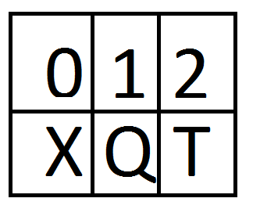push(X): X 🡨
3. push(Q): XQ 🡨
4. push (Y): XQY🡨
5. push(M): XQYM🡨 FINAL STACK:
6. pop(): XQY 🡪M
7. pop(): XQ 🡪Y
8. push(T): XQT🡨

Make sure to label the top entry of your stack after the last operation has been executed.